Homework 1
- Use the internet to research Norman, Oklahoma’s actions under the Lead and Copper Rule Revisions, and summarize these actions in a list of typed points. (I will only read typed answers!) Cite all references using this style guide: https://pubs.acs.org/doi/full/10.1021/acsguide.40303.

Answer:
Actions Taken by Norman, Oklahoma Under the Lead and Copper Rule Revisions:
- Creation of Local Lead Service Line Inventory:
In October 2024, Norman City established a local Lead Service Line Inventory to ensure compliance with the Lead and Copper Rule Revisions introduced by the Environmental Protection Agency (EPA). This inventory is designed to identify and monitor lead service lines and improve communication with residents.
- Notification to Affected Customers:
Approximately 5,000 letters were sent to water utility customers identified as having a Lead Water Service Line, Galvanized Requiring Replacement Water Service Line, or Unknown Material Water Service Line. The city notified these customers that the unknown service lines had not yet been surveyed but would be inspected as soon as possible.
- Survey and Replacement Efforts:
The city staff is diligently working to survey over 40,000 water service connections to determine the material composition of the service lines. Property owners are encouraged to work with licensed plumbers to address and replace private lead service lines at their own expense if needed.
- Public Engagement and Information Sharing:
Residents are encouraged to review the online inventory and receive updates about the initiative. The city also provides educational resources to promote proactive measures for reducing lead exposure.
- Lead Monitoring and Continued Compliance:
Norman has consistently monitored lead levels in homes under the Lead and Copper Rule since its inception and has never found lead above the action limit. However, efforts continue to enhance safety and transparency regarding lead service lines.

References:
- City of Norman. Norman Officials Share Update on Lead Service Line Inventory Initiative. https://normanok.gov/news/norman-officials-share-update-lead-service-line-inventory-initiative (accessed Jan 16, 2025).
- Environmental Protection Agency. Lead and Copper Rule Revisions. https://www.epa.gov/ground-water-and-drinking-water/lead-and-copper-rule-revisions (accessed Jan 16, 2025).

2.Go to the IRIS database (https://iris.epa.gov/AtoZ/?list_type=alpha) and find the entry for methoxychlor.
a. Show how the RfD for methoxychlor oral exposure was calculated from the NOEL
(i.e., show the calculations). You must include units in your calculations.
Answer:
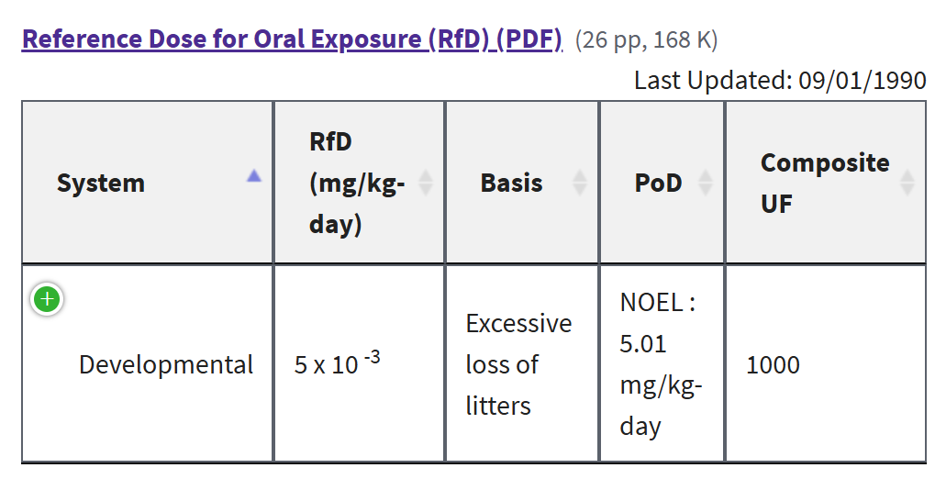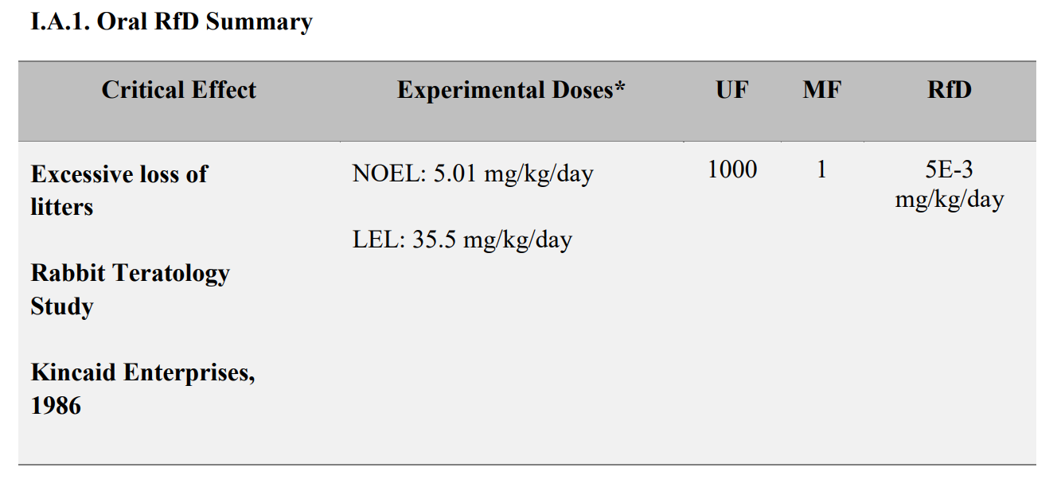
NOEL>=NOAEL
NOEL (No Observed Effect Level)
NOAEL (No Observed Adverse Effect Level)
$RfD= \frac{NOAEL}{UF ×MF}= \frac{PoD (NOEL)}{UF × MF}=\frac{5.01\frac{mg}{kg}-day}{1000 X 1}$ = 5E-3 mg/kg-day

b. Show how the MCLG for methoxychlor was calculated from the RfD. You must
include units in your calculations. Assume the same values for body weight, relative
source contribution, and water consumption rate as for our in-class example for
glyphosate.
Answer:
$MCLG= \frac{RfD\left(5E-3 \frac{mg}{kg d}\right) ×BW \left(70Kg\right)×RSC(0.2)}{CR (\frac{2L}{d})}$ = 0.035 mg/L
c. Compare the MCL and the MCLG for methoxychlor, i.e., is the MCL equal to or
greater than the MCLG? MCLs and MCLGs for contaminants regulated under
SDWA are given here: https://www.epa.gov/ground-water-and-drinking-water/national-primary-drinking-water-regulations. Note: MCLGs are called “Public Health
Goals” in this table.
Answer:
Yes, the MCL and MCLG are equal.
d. Click on the link called “Reference Dose for Oral Exposure” and describe in 2-3
typed sentences the study upon which the methoxychlor RfD is based.
Answer:
The RfD for Methoxychlor is 0.04 mg/L. This value was determined based on studies that observed reproductive difficulties, such as increased reproductive issues in F3b offspring. The primary sources of Methoxychlor in drinking water are runoff or leaching from insecticides used on fruits, vegetables, alfalfa, and livestock.

e. What is methoxychlor and why is it used? Answer in one typed sentence.
Answer: Methoxychlor is an organochlorine insecticide used to control pests on crops, livestock, and in homes due to its effectiveness against a wide range of insects.

3.Textbook problem 4.8(A).
Calculate the hydraulic residence time and volume of a PFR required to achieve the given effluent concentration for the reaction given below (to be selected by the instructor).
a. Q = 39 ML/d, Ci = 100$μg/L$, CE = 2.0$μg/L$, first-order decay reaction, k = 0.375 min⁻¹.
Answer:
$$\ln{\frac{Ce}{Ci}}= -kt$$
T = $\ln{\frac{Ce}{Ci}}×$(-1/K) =
V = Q×T =
4. Textbook problem 4.9(D). Assume the reaction is second order with respect to the same reactant, i.e., -dC/dt = kC2. For the system given in Problem 4-8 (to be selected by the instructor), calculate the hydraulic residence time and volume if the reactor is a CMFR.
Answer:

